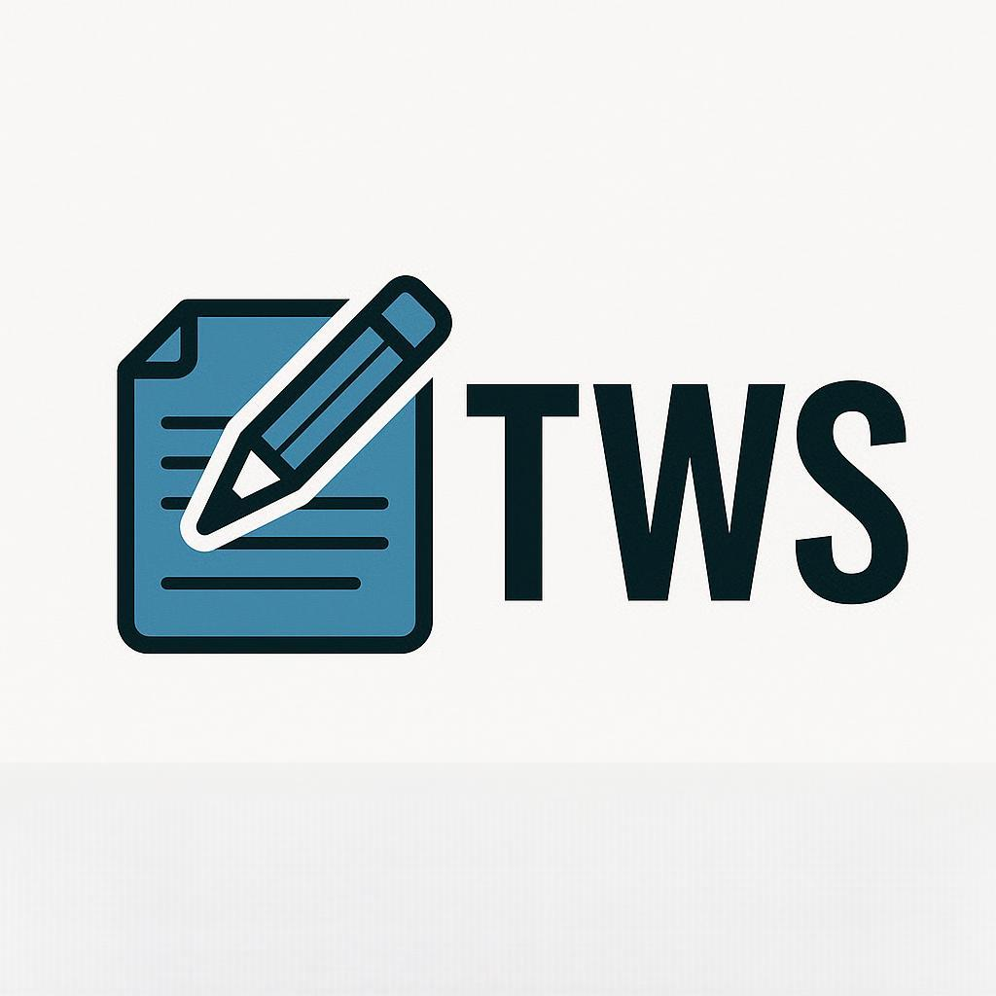

Memorandum

To: Department Heads

From: Starlan Davis

Sustainability Coordinator

Date: 8 June 2025

Re: Transition to Eco-friendly Practices

In the coming weeks, Technical Writing Solutions will be implementing a program aimed at significantly reducing our waste production.

A document will be sent to each department head, via both email and physical form, to provide a detailed explanation of the new policies. In incorporating these changes, it is crucial that all employees of Technical Writing Solutions participate in order for the program to be successful.

In light of the importance of this program, please be sure to promptly inform your team of the upcoming changes, as well as ensure that you are leading by example and complying with all policies.

If you have any questions, please contact me at sdavis@technicalsolutions.com or 404-123-4567.

Best regards,

Starlan Davis

Sustainability Coordinator